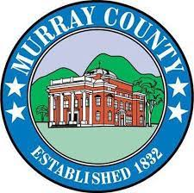

MURRAY COUNTY PUBLIC MEETING
PUBLIC NOTICE

The Murray County Commissioner will hold a Public Meeting on Tuesday,
December 30, 2025, at 1:00 P.M. in the Hearing Room of the Murray County Annex.
The public is invited and encouraged to attend.

TENTATIVE AGENDA
- Call to Order
- Approval of Agenda
- New Business

- Item A: BID OPENING: Murray County Fire Station No. 7

Bid Notice was published in December 17th & December 24th edition(s) of The Chatsworth Times, and on the Georgia Procurement website in November 2025.

4. Adjournment

Murray County Government is committed to ensuring that our programs, services, facilities, and meetings are accessible to all individuals, including those with disabilities. In accordance with the Americans Disabilities Act (ADA), we strive to eliminate barriers and provide reasonable accommodations to ensure equal access and opportunity. If you need special accommodation(s) for a meeting, please give a minimum of 48 hours’ notice, so that, if necessary, we may coordinate with other departments.

